

**American International University-Bangladesh**

**Leaf Color Detecting System**

**Final Project Submission**

Submitted By

Baki, Md. Abdullah Al 14-27968-3

Alam Marzia 14-27969-3

Nabi Nusrat 14-28057-3

Chowdhury, Jahiruddin 15-28397-1

Software Development and Project Management

Section: B

Faculty: Mohammad Mahmudul Hasan

Department of Computer Science

American International University-Bangladesh

September, 2018.

**Concept:**

**Target Market and Audience:**

* The target market or audience of this project are Farmers, NGO workers who works in farming sector, Industrial Plantation (Tea, Sugar, Timber etc.) Projects and Forestry Officers.

**Problem and Solution:**

**Problems:**

* Food crops, Trees and plantation projects suffer from various diseases. If the impact of these dieses is high, farmers and projects suffers financially also the production decreases. Even at low rate, spreading of a disease leaves notable amount of damage behind.
* Farmers and plantation projects use pesticides whenever a disease is occurred. And often, they overdone the dose of pesticides. “The more, the better”, this tendency leads to unnecessary use of pesticides and harms the environment.
* Crops and plantation also suffers from Nutrition Deficiencies. Soil may lack an important element that is essential for the growth of the crops. This impacts the production. Also denies the targeted financial achievement.
* Due to Nutrition Deficiencies, farmers and projects use fertilizers. And like before, they often overuse it. They apply an amount of fertilizer that doesn’t require. And fertilizers cost a lot of money.

**Solutions:**

* Whenever a disease accrues, the first symptom can be seen on the leaves. They become yellow or show black/brown spots. The change in a leaf’s physical appearance can tell us the name of disease and even the amount of treatment it needs.
* Also, with the nutrition deficiency, leaves shows the first sign. Leaves show different shades of color due to lack of different element in the soil. The element can be identified from the color and also the right amount of fertilizer can be calculated.

**Class Diagram:**

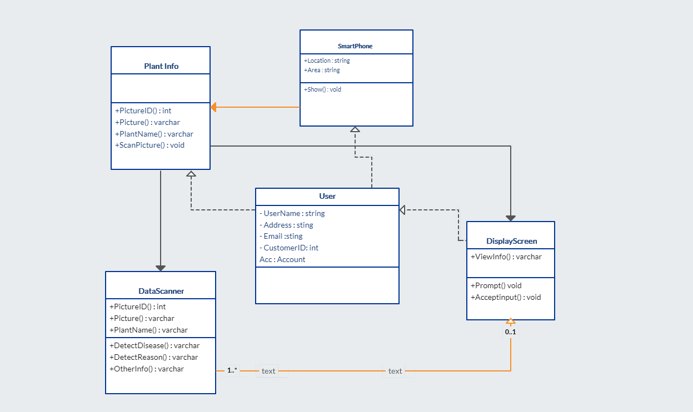

**ER Diagram:**

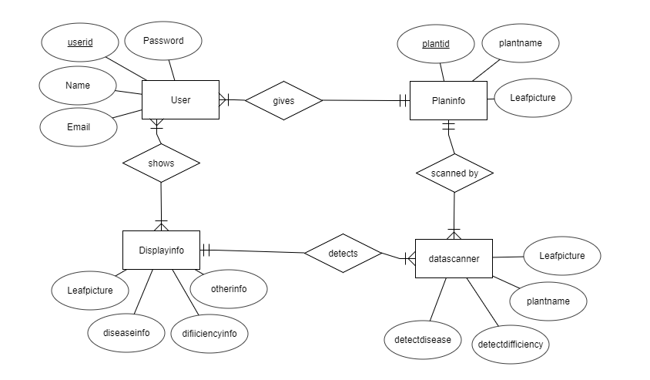

**Use Case Diagram:**

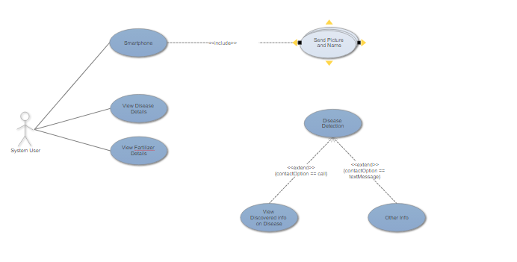

## Activity Plan:

## Activities with their duration and precedence work:

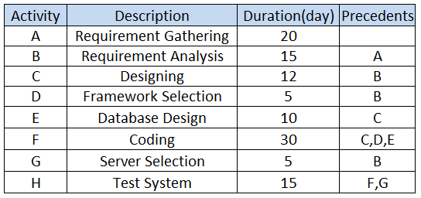

## Network Diagram:

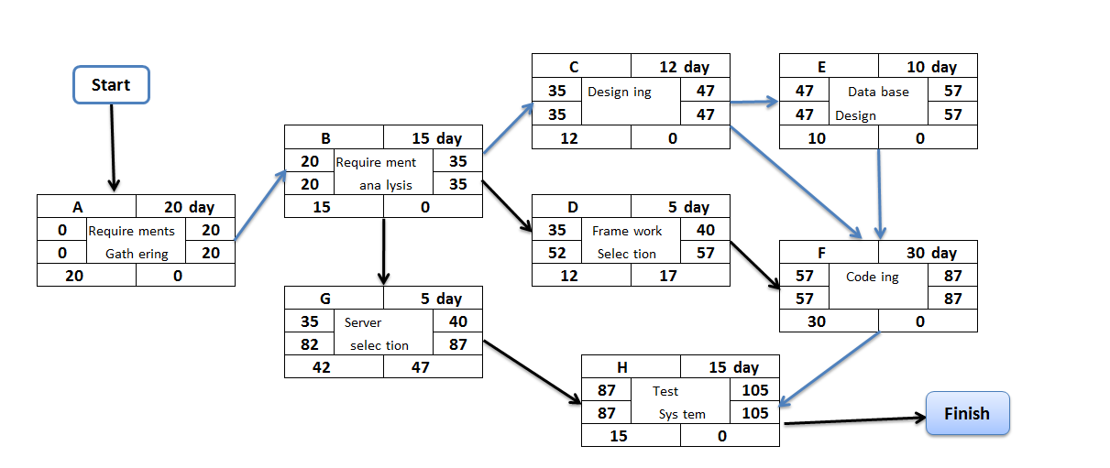

## Effort Estimation Plan:

**Effort = PM = Coefficient<Effort Factor>*(SLOC/1000) ^P**

##### =3.6*(3400/1000)^ 1.20

##### Estimation is the process of finding an estimate, or approximation, which is a value that can be used for some purpose even if input data may be incomplete, uncertain, or unstable.

Estimation determines how much money, effort, resources, and time it will take to build a specific system or product. Estimation is based on −

* Past Data/Past Experience
* Available Documents/Knowledge
* Assumptions
* Identified Risks

**Effort Estimation** **by** **CoCoMo (Constructive Cost Model):**

The three basic steps in Software Project Estimation are

* **Organic:** Relatively small, simple software projects in which a small team with good application experience work to a software development project (e.g. showing VUES information to webpage)
* **Semidetached:** An intermediate (in size and complexity) software project in which teams with mixed experience levels works in a mix of hardware and software application (e.g. biometric log-in time saved in VUES database)
* **Embedded:** A software project that must be developed within a strongly coupled to hardware environment (e.g. biometric device, elevator)

|  |  |  |  |
| --- | --- | --- | --- |
| **Software Project Type** | **Coefficient<Effort Factor>** | **P** | **T** |
| Organic | 2.4 | 1.05 | 0.38 |
| Semi-detached | 3.0 | 1.12 | 0.35 |
| Embedded | 3.6 | 1.20 | 0.32 |

Our Project is embedded because our project works on a hardware system (Smartphone). So our effort estimation based on CoCoMo model is calculated below:

**PM** : Person-months needed for project  
**SLOC :** Source lines of code = 3400  
**P :** Project complexity (Embedded) = 1.20  
**DM :** Duration time in months for project  
**T :** SLOC-dependent coefficient (Embedded) = 0.32  
**ST :** Verge staffing necessary

**Effort = PM = Coefficient<Effort Factor>*(SLOC/1000) ^P**

=3.6*(3400/1000) ^1.20

= 15.63

**Development time = DM = 2.50*(PM) ^T**

**=** 2.50 * (15.63) ^0.32

= 6.03

**Required number of people = ST = PM/DM =** 15.63/6.03=2.59=3 people

**Risk analysis:**

**Risk Management Plan:**

* Product size (PS)
* Business impact (BU)
* Customer characteristics (CU)
* Process definition (PR)
* Development Environment (DE)
* Technology to be built (TE)
* Staff size and experience (ST)
* **RMMM** = Risk Mitigation, Monitoring and Management Plan

**Impact values:**

* Catastrophic = **1**
* Critical = **2**
* Marginal = **3**
* Negligible = **4**

**Risk Table:**

|  |  |  |  |  |
| --- | --- | --- | --- | --- |
| Risks | Category | Probability | Impact | RMMM |
| 3. Requirements aren't clearly defined | PS | 45% | 2 | Requirements scrubbing (cleaning), prototyping |
| 4. Requirements need to change for business reasons. | BU | 20% | 2 | Change control, incremental development |
| 5. Workers can drop out middle of the project. |  | 20% | 3 | Staffing with experienced personnel |
| 6. Workplace instruments can fall out | PS | 25% | 1 | Benchmarking (evaluate by comparison with standard), inspections, formal specifications, contractual agreements, quality controls |
| 7. Customer can change requirements | PS | 50% | 1 | Change control, incremental development |
| 8. There won’t be time in the QA process to validate equally on all cases from different operating systems. | PR | 45% | 2 | Planning needs to be more accurate to keep enough time for validation. |
| 9. Limited manpower to complete the project before deadline. | ST | 30% | 1 | Give attention about work distribution. |
| 10. Bugs in development tools. | DE | 28% | 3 | Implement robust preventive maintenance plans. |
| 11. Delivery deadline will be tightened | BU | 50% | 1 | Develop early delivery schedule. |
| 12. Staff inexperienced | ST | 35% | 3 | Train up by old staff |
| 13. Staff turnover will high | ST | 55% | 2 |  |
| 14. Release of more improved technology. | TE | 45% | 4 | Software does have scopes to adapt new technology following certain protocols. |

**Resource analysis:**

|  |  |  |  |  |
| --- | --- | --- | --- | --- |
| Task name | Days | Start | Resources | Labor unit |
| Requirement gathering | 1 | 01 August, 2018 | Baki, Md. Abdullah Al | 3 |
| Obtain teacher’s approval | 1 | 02 August, 2018 | Alam Marzia | 2 |
| Requirement analysis | 3 | 03 August, 2018 | Alam Marzia | 3 |
| Designing | 7 | 06 August, 2018 | Baki, Md. Abdullah Al | 3 |
| Framework selection | 4 | 13 August, 2018 | Chowdhury, Jahiruddin | 4 |
| Coding | 7 | 17 August, 2018 | Chowdhury, Jahiruddin | 4 |
| Server selection | 4 | 24 August, 2018 | Nabi Nusrat | 2 |
| Test system | 5 | 28 August, 2018 | Nabi Nusrat | 4 |

**Acknowledgement:**

At the End of the project, we want to give thanks to our respected Faculty Md. Mahmudul Hasan Sir.